Fall 2023 Wellness Webinars

Copy and paste this content into an email to share!
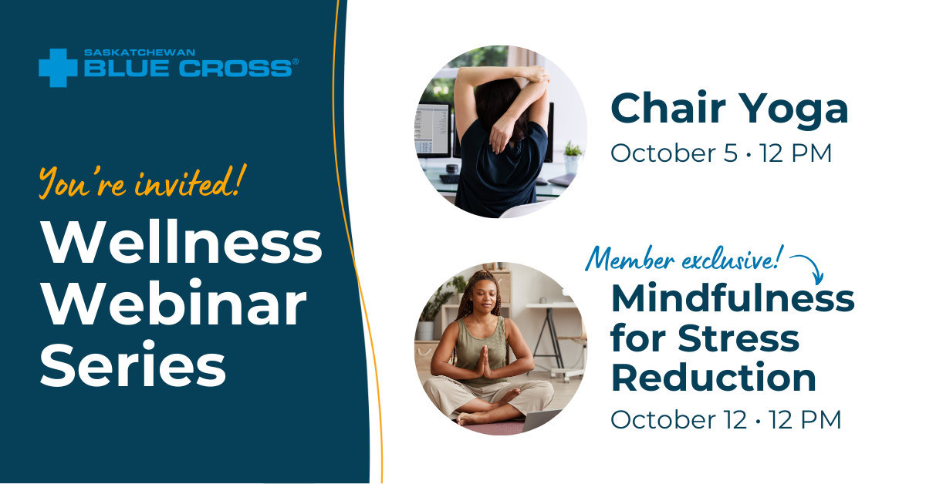
Saskatchewan Blue Cross is hosting two more Wellness Webinars this fall! Powered by Twello, join us to take 30 minutes over the lunch hour for some Mindful Movement on October 5th and to chat about Mindfulness for Stress Reduction on October 12th.

Mindful Movement/Chair Yoga
October 5, 2023
12:00pm - 12:30pm

This class features simple stretches to wake up the mind and body. All stretching poses are great for beginners and experts alike, no experience required! Your certified yoga teacher will be happy to provide modifications for each posture so all individuals may enjoy the health benefits of yoga, no matter their fitness level. No yoga or special equipment required, just bring yourself and a chair!

Register here: Webinar Registration - Zoom

MEMBER EXCLUSIVE: Mindfulness for Stress Reduction
October 12, 2023
12:00pm - 12:30pm

Self-care is essential to maintaining positive mental health and reducing stress. And self-care isn't just about bubble baths! This class will look at two techniques you can use to improve your own self-care and support others around you. No special equipment or clothing required.
﻿
Register here: Webinar Registration - Zoom

