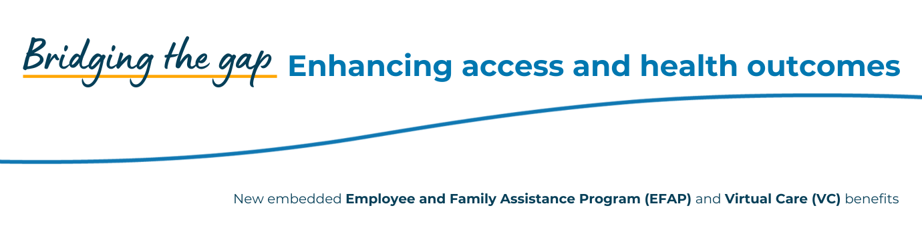Access support anytime, anywhere with your new benefits from Saskatchewan Blue Cross!
You’re invited to join a short, informative webinar on two new benefits available to you: Employee and Family Assistance Program (EFAP) and Virtual Care.
During the webinar, you’ll learn:
- What these programs offer — from mental health support and life coaching to 24/7 access to Canadian Nurse Practitioners
- How to easily access services from your phone or computer
- Real-life examples of how these tools can support your health, wellness and work-life balance
- Answers to common questions about privacy, eligibility and booking appointments
- How these programs can help bridge the gaps in today’s healthcare system — including long wait times, rural access and more
You’ll hear directly from trusted partners at Homewood Health and Cleveland Clinic Canada, who will walk you through these services and answer your questions.
Learn how to make the most of your new benefits and get support where and when you need it.
Register for one of the following webinar times:
- Thursday, September 11, 2025, from 1:00 pm - 1:30 pm
- Wednesday, September 17, 2025, from 10:00 am - 10:30 am

